‎ A.I Lab Manual By Saqib Hussain

Roll No: BIT-23F-014

Python Programming Tasks (lab no 5)

Python Programs: Basic to Advanced

**1. Basic Task: Check if a number is positive, negative, or zero**

# Basic Task  
num = float(input("Enter a number: "))  
  
if num > 0:  
 print("The number is positive.")  
elif num < 0:  
 print("The number is negative.")  
else:  
 print("The number is zero.")

***Output:***

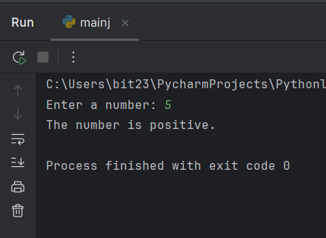

**2. Intermediate Task: Check if a number is even or odd**

# Intermediate Task  
num = int(input("Enter an integer: "))  
  
if num % 2 == 0:  
 print("The number is even.")  
else:  
 print("The number is odd.")

***Output:***

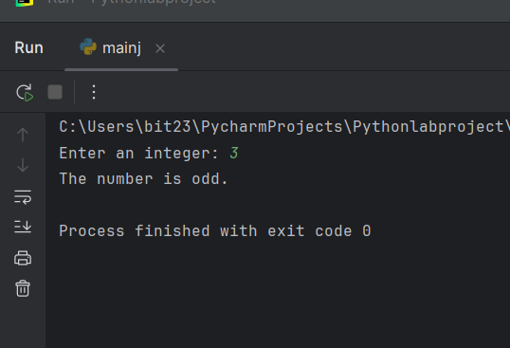

**3. Advanced Task: Grade Evaluation**

# Advanced Task  
marks = int(input("Enter your marks: "))  
  
if marks > 80:  
 print("Excellent")  
elif 60 <= marks <= 80:  
 print("Good")  
else:  
 print("Needs Improvement")

***Output:***

